CM12004 – Discrete Maths & Databases
Database Coursework Template

This template provides spaces to provide the evidence necessary for each task presented in the databases coursework brief.
- Evaluate and improve a database design.
  - Evaluate the logical entity-relationship diagram given in the scenario.
Issue | Detail
Example: Relation A does not have a primary key. | Relations require primary keys.
There is no Station Entity | A station is an valid entity in the scenario, and so should have it’s own entity in the ERD diagram, with all the fields mentioned, such as Latitude/Longitude, Setup Date, Setup Member.
There should be a relation between StationID in Maintenance and Asset and a Station entity | Without the Station entity, the two StationID fields are not related, which could cause consistency errors.
The Maintenance → Crew Member relation is set up incorrectly | The Maintenance → Crew Member relation is setup to be 0 or many, which is incorrect, as a maintenance cannot be performed without a crew member, and cannot be performed by more than one crew member. The relation should be 1 mandatory instead.
The Crew Member → Maintenance relation is set up incorrectly | The Crew Member → Maintenance relation is setup to be 1 mandatory, but should be 0 or many instead, as a crew member may not have necessarily performed a maintenance yet, but can also perform more than one.
The data type of When and Installation Date is incorrect. | The data type of When and Installation Date is set to be TEXT and INTEGER respectively, however, these are likely dates, so the DATE type would be better suited for these fields.
Model No. is a duplicated field. | Model No. is repeated twice in the Asset entity, which is an example of data duplication, and could also cause consistency problems. The field should only exist once.
Model attributes should be split into their own entity. | Model attributes, such as Model No., Manufacturer, Type, should be split into their own entity, as these are attributes that will be commonly repeated otherwise, especially if the station has more than one of the same model.
Firstname and Surname do not need to be part of the Primary Key | The CrewID field can be expected to be unique, so the Firstname and Surname fields do not have to be part of the primary key for the Crew Member entity.
‘WHEN’ is a protected keyword in SQL | As ‘WHEN’ is a keyword in SQL, if the database is created with a column with the name of ‘When’, an syntax error will be created. Instead, the name should be changed to something like ‘Maintenance Date’
The composite foreign key for maintenance is incorrect. | The composite foreign key for maintenance is incorrect, as it doesn’t allow the same crew member to perform maintenance on the same asset more than once. The key should also include the ‘Maintenance Date’ field.

[5]
  - Based on your critique construct a more appropriate logical entity relationship diagram.
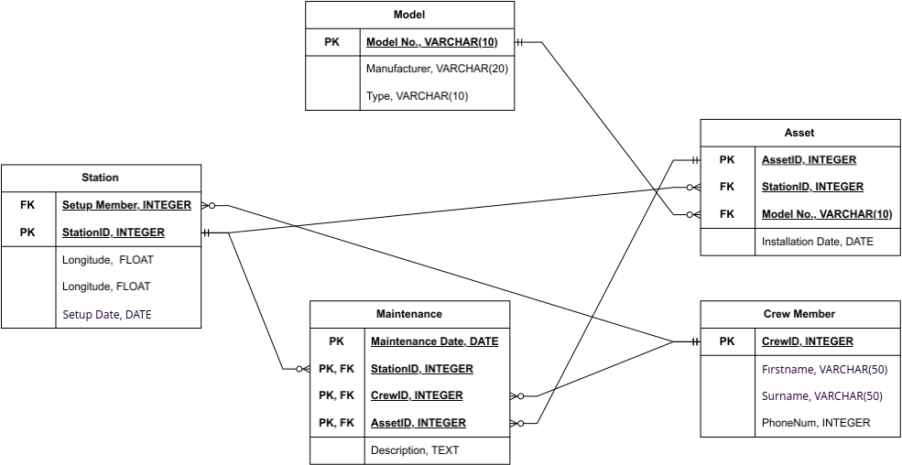

[10]

- Implement your logical entity-relationship diagram using SQL’s Data Definition Language (DDL).
CREATE TABLE Model (
model_no VARCHAR(10) PRIMARY KEY,
manufacturer VARCHAR(20),
type VARCHAR(10));

CREATE TABLE Station (
station_id INTEGER PRIMARY KEY,
setup_member INTEGER NOT NULL,
longitude FLOAT,
latitude FLOAT,
setup_date DATE,
FOREIGN KEY (setup_member) REFERENCES CrewMember(crew_id)
);

CREATE TABLE Asset (
asset_id INTEGER PRIMARY KEY,
station_id INTEGER NOT NULL,
model_no INTEGER NOT NULL,
installation_date DATE,
FOREIGN KEY (station_id) REFERENCES Station(station_id),
FOREIGN KEY (model_no) REFERENCES Model(model_no)
);

CREATE TABLE Maintenance (
station_id INTEGER NOT NULL,
crew_id INTEGER NOT NULL,
asset_id INTEGER NOT NULL,
setup_date DATE,
description TEXT,
PRIMARY KEY (station_id, crew_id, asset_id),
FOREIGN KEY (station_id) REFERENCES Station(station_id),
FOREIGN KEY (crew_id) REFERENCES CrewMember(crew_id),
FOREIGN KEY (asset_id) REFERENCES Asset(asset_id)
);

CREATE TABLE CrewMember (
crew_id INTEGER PRIMARY KEY,
firstname VARCHAR(50),
surname VARCHAR(50),
phone_num INTEGER
);

[5]

- Provide the SQL queries necessary to carry out required functions.
  - Write a query to return the CrewID’s of all crew members with the surname ‘Brimble’.
SELECT crew_id FROM CrewMember WHERE CrewMember.surname='Brimble';

[2]
  - Write a query which returns the firstname and surname of all crew members who were involved in maintenance activity for the asset with ID 101.
SELECT CrewMember.firstname, CrewMember.surname FROM CrewMember JOIN Maintenance ON CrewMember.crew_id = Maintenance.crew_id WHERE Maintenance.asset_id = 101;

[2]
  - Write a query to retrieve a list of assets which have no maintenance activity.
Select Asset.asset_id FROM Asset LEFT JOIN Maintenance ON Asset.asset_id = Maintenance.asset_id WHERE Maintenance.asset_id IS NULL;

[2]
  - Write a query to output the ID of each asset and the number of maintenance records for each asset in ascending order.
SELECT Asset.asset_id, COUNT(Maintenance.asset_id) FROM Asset LEFT JOIN Maintenance ON Asset.asset_id = Maintenance.asset_id GROUP BY Asset.asset_id ORDER BY COUNT(Maintenance.asset_id) DESC;

[2]
  - Write a query to output a list of crew members and the total number of maintenance records they’ve entered for any asset manufactured by Hitachi.
SELECT CrewMember.crew_id, CrewMember.firstname, CrewMember.surname, COUNT(Maintenance.crew_id) FROM CrewMember JOIN Maintenance ON CrewMember.crew_id = Maintenance.crew_id JOIN Asset on Maintenance.asset_id = Asset.asset_id JOIN Model ON Asset.model_no = Model.model_no WHERE Model.manufacturer='Hitachi' GROUP BY CrewMember.crew_id;

[2]

